# watsonx Orchestrate Lab 1b:

# Building A Custom Skill

Objective

Sometimes, the out of the box skills might not be enough to achieve what you want to do. Or, your organization may have a custom tool, function, which you wish to incorporate into a workflow. In this lab, you will learn how to set up a custom skill using a custom-made Open API Script. The Open API specifications are connected to three agents **– “Get Historic Sales”, “Time Series Forecasting and “Calculate Reorder Quantity”** which we’ve created using a python code using watsonx.ai and crew.ai in the backend.

Use Case:

In this lab, you will learn how to configure custom skills for text2sql to retrieve historical sales and quantity data.

The high-level steps to accomplish this are as follows:

1. Create a new Skill using the custom Open API specification.

2. Enhance and Publish the Skill.

3. Add your custom skill to Skill Catalog.

4. Bringing in a ML Predictive Model

5. Add Skills to AI Chat

6. Test the Skills.

## Configure Custom Skills Script

As we will be using a shared instance for this workshop, we will need to make slight modification to one of the custom skill script to avoid confusion and skills clashes.

1. Download the text2sqp_openapi.json custom skills script from [here](https://ibm.box.com/s/xc3x0j0n2hyolhlmev6yxule5ddshmwn).
2. Open up the script with a code editor or notepad and update the following
   1. Update title to “[Your Name] Get Historic Sales”
   2. Update description to “[Your Name] API that converts…..”
   3. Update summary to “[Your Name] Text2SQL with Crew AI”
   4. Update description to “[Your Name] Takes a natural language query…
   5. Update operationid to “[Your Name]processQuery” **(no spacing)**

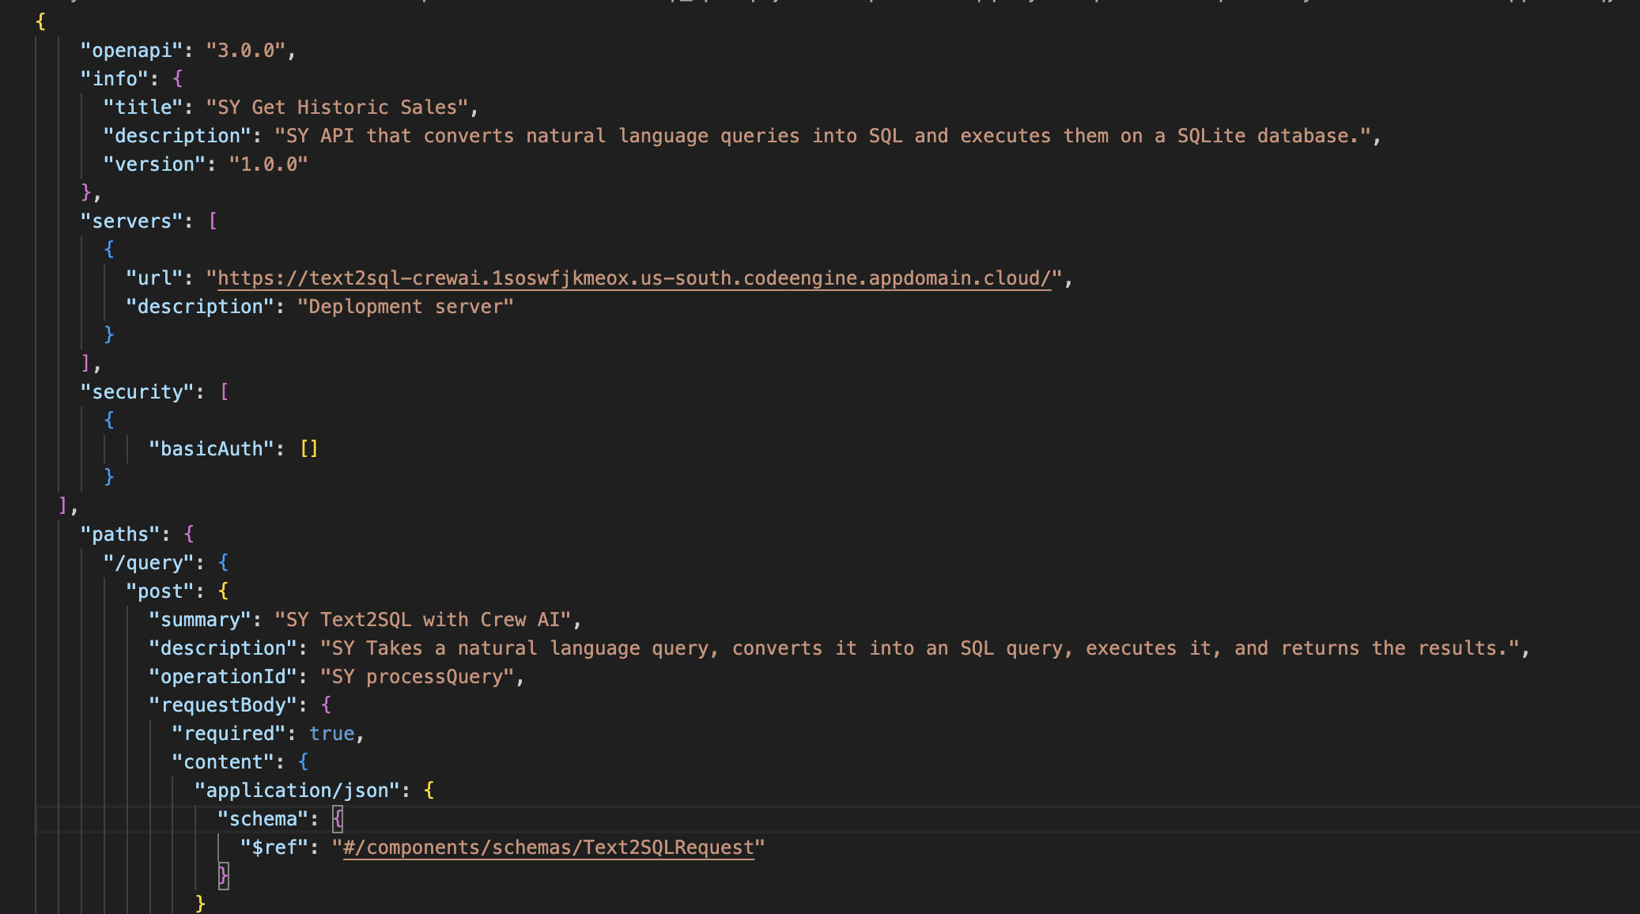

1. Save the script and we will now upload to WxO.
2. Due to time constraint, the rest of the custom skills have been configured within the tenant.

## Configure Custom Skills

1. Go to Skill Studio from the top left hamburger menu

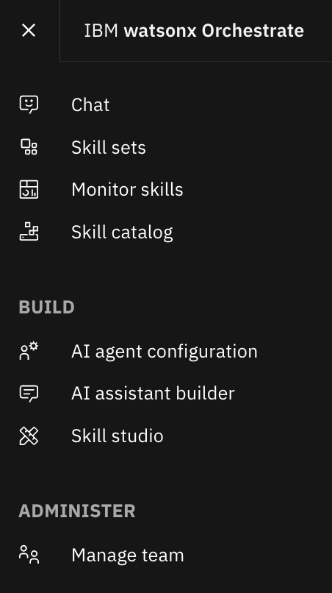

1. Create a new skill by using the option “Import API”

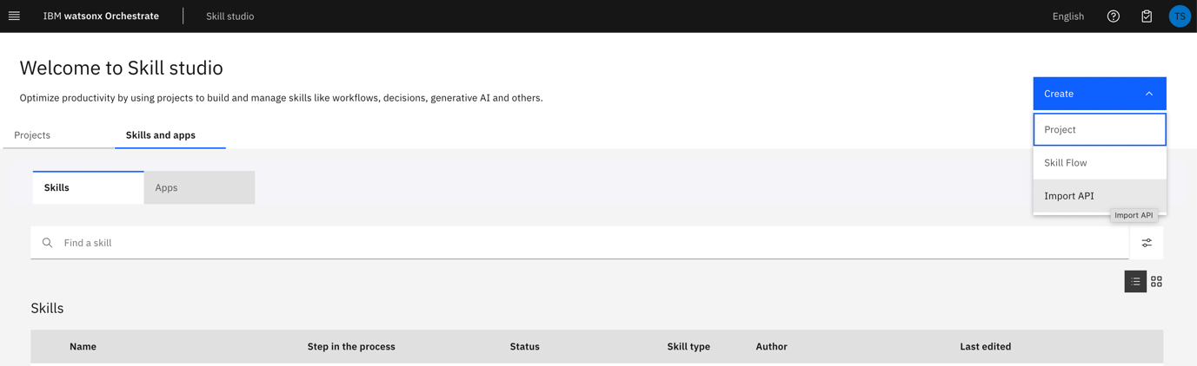

1. Import the file text2sql_openapi.json from your local.

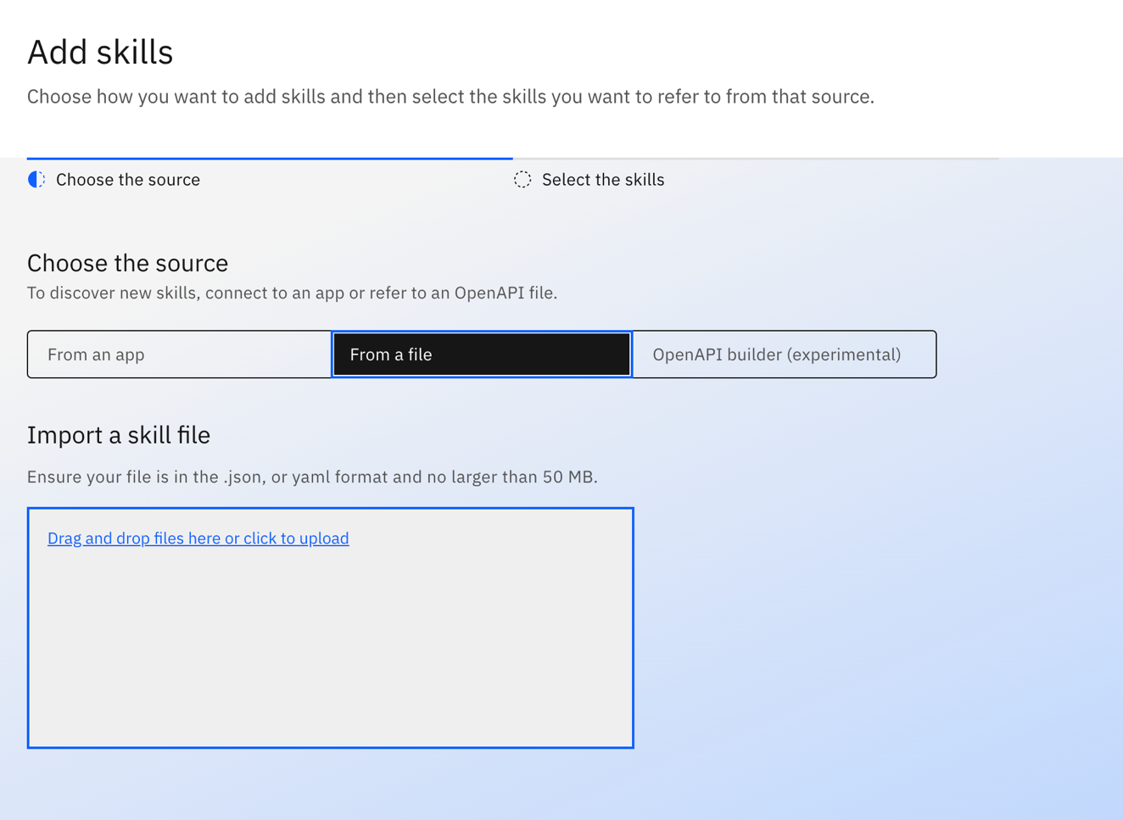

1. Select the Skill “[YourName] Text2SQL with Crew AI” and Add.

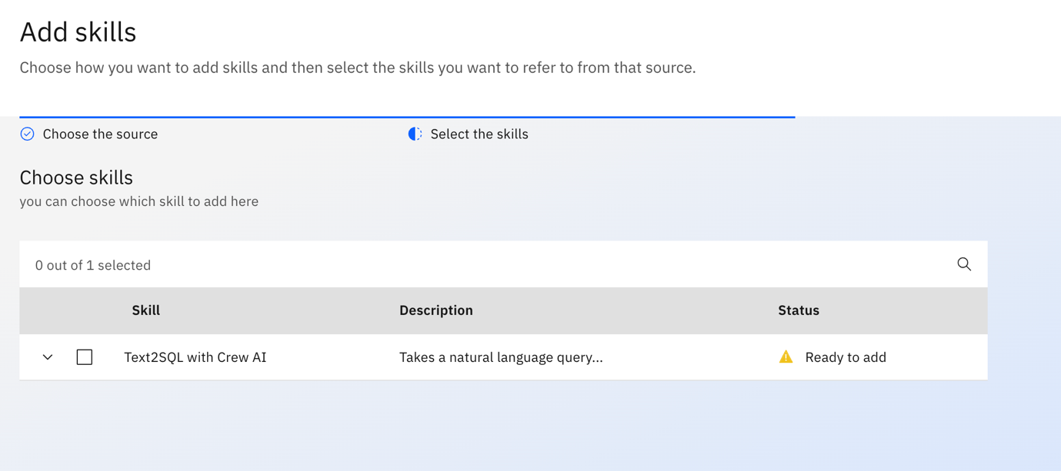

After adding the skills, the status would be “Ready to publish” like as follows:

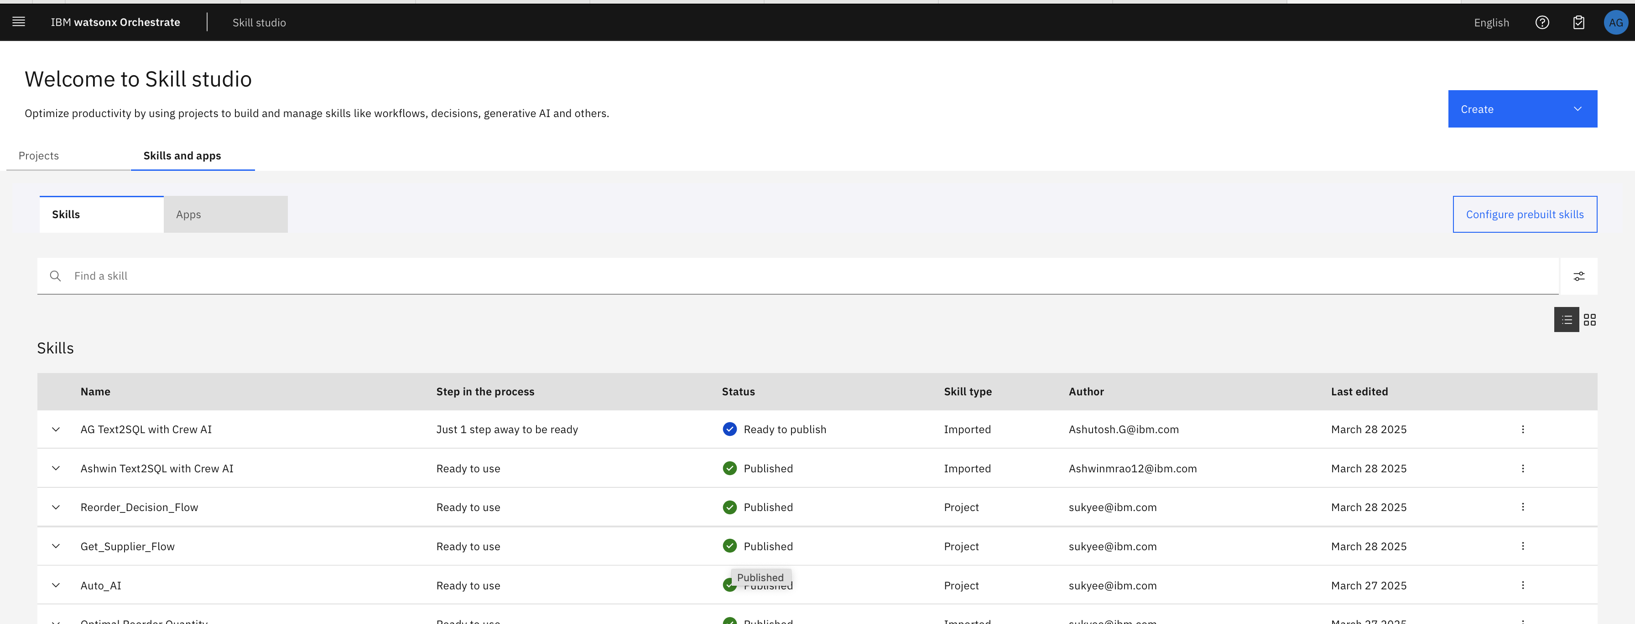

1. Now, Click on the menu of this skill ( three dots in the last) once it has been imported successfully and then select “Enhance this Skill”.

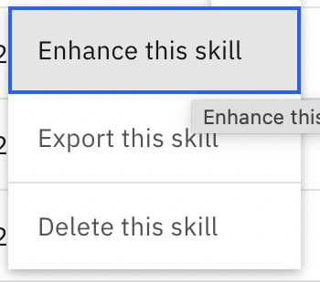

You will see the following image:

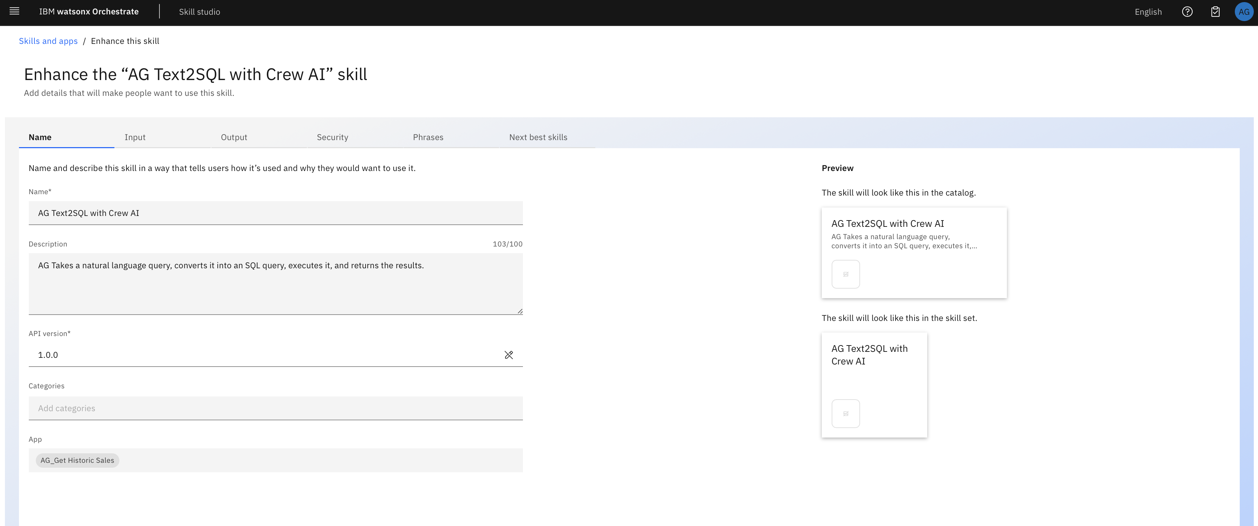

1. Publish the Skill by clicking the “Publish” button.

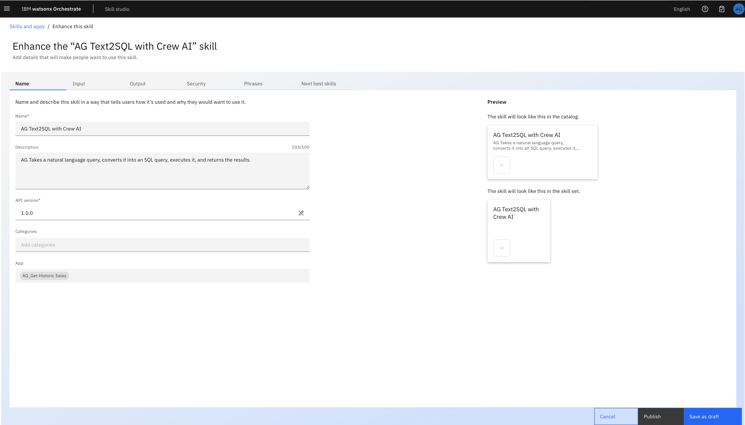

After successfully publication, you can see how the status got change on the skill catalog window.

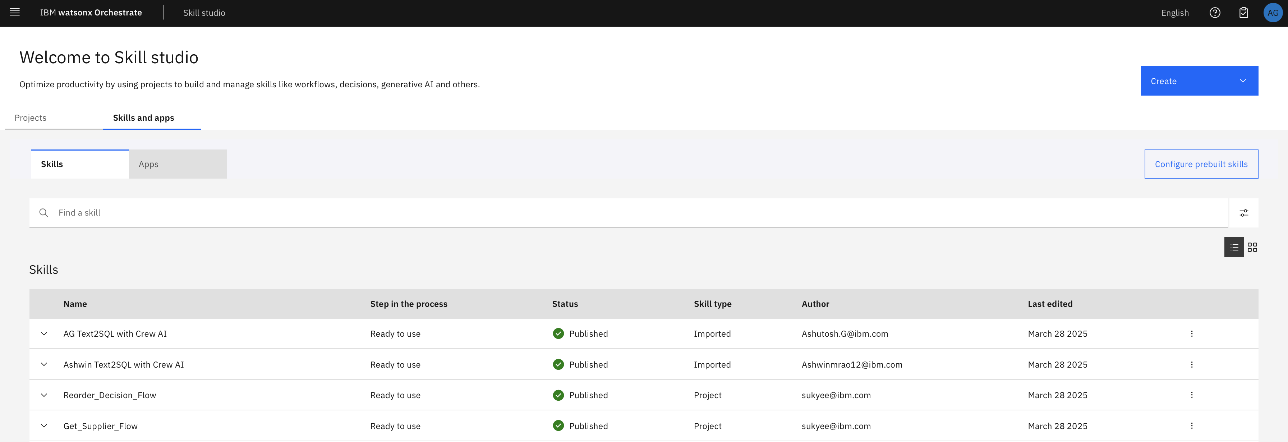

1. Go to **Skill Catalog** from the left-hand hamburger menu and search for “[YourName] Get Historic Sales”. Once you found, select the App. **\*\*Sometimes the app takes a while to load. You can refresh the page if the search fails.**

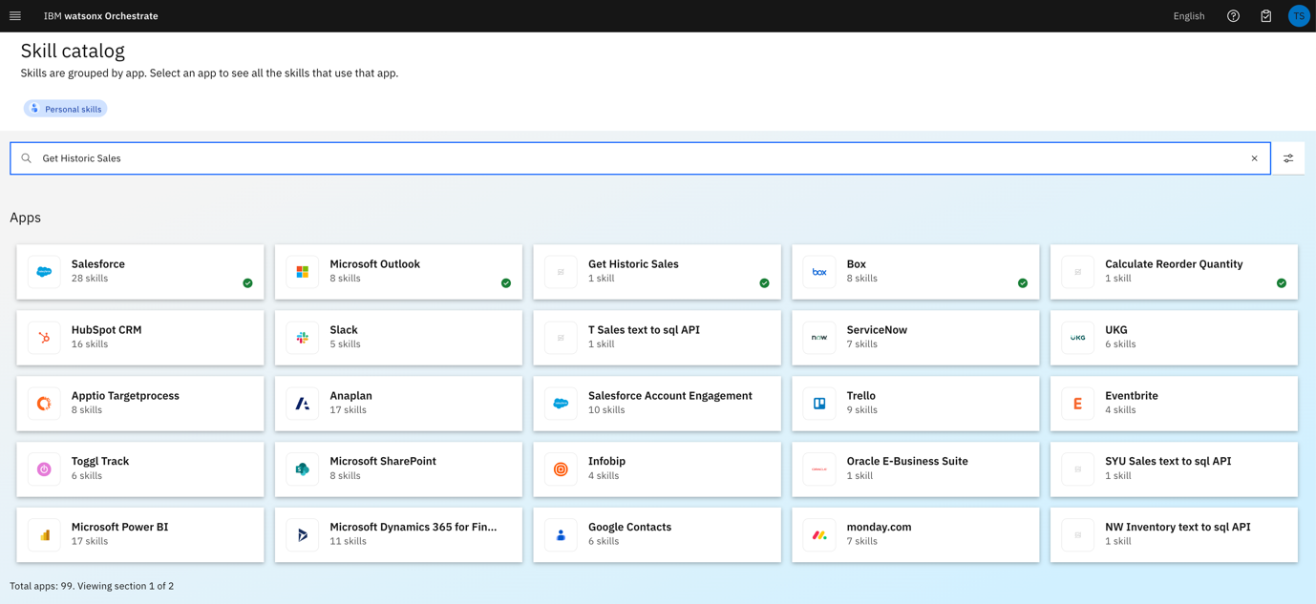

1. Once you selected the app, now add the “[YourName] Text2SQL with Crew AI” skill by clicking on the “Add Skill” button.

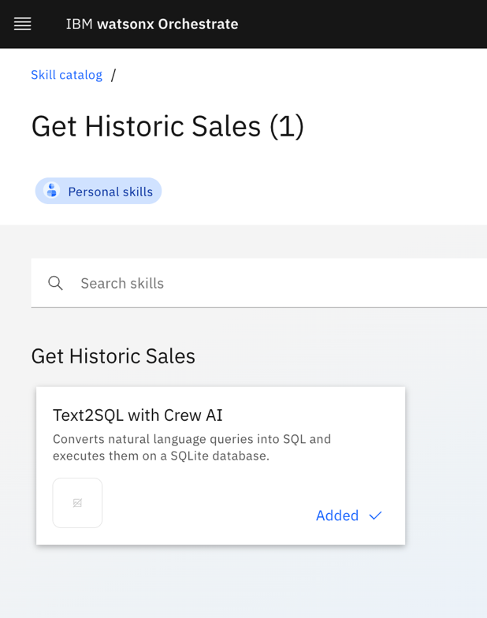

1. Connect the app by clicking on “Connect App” button.

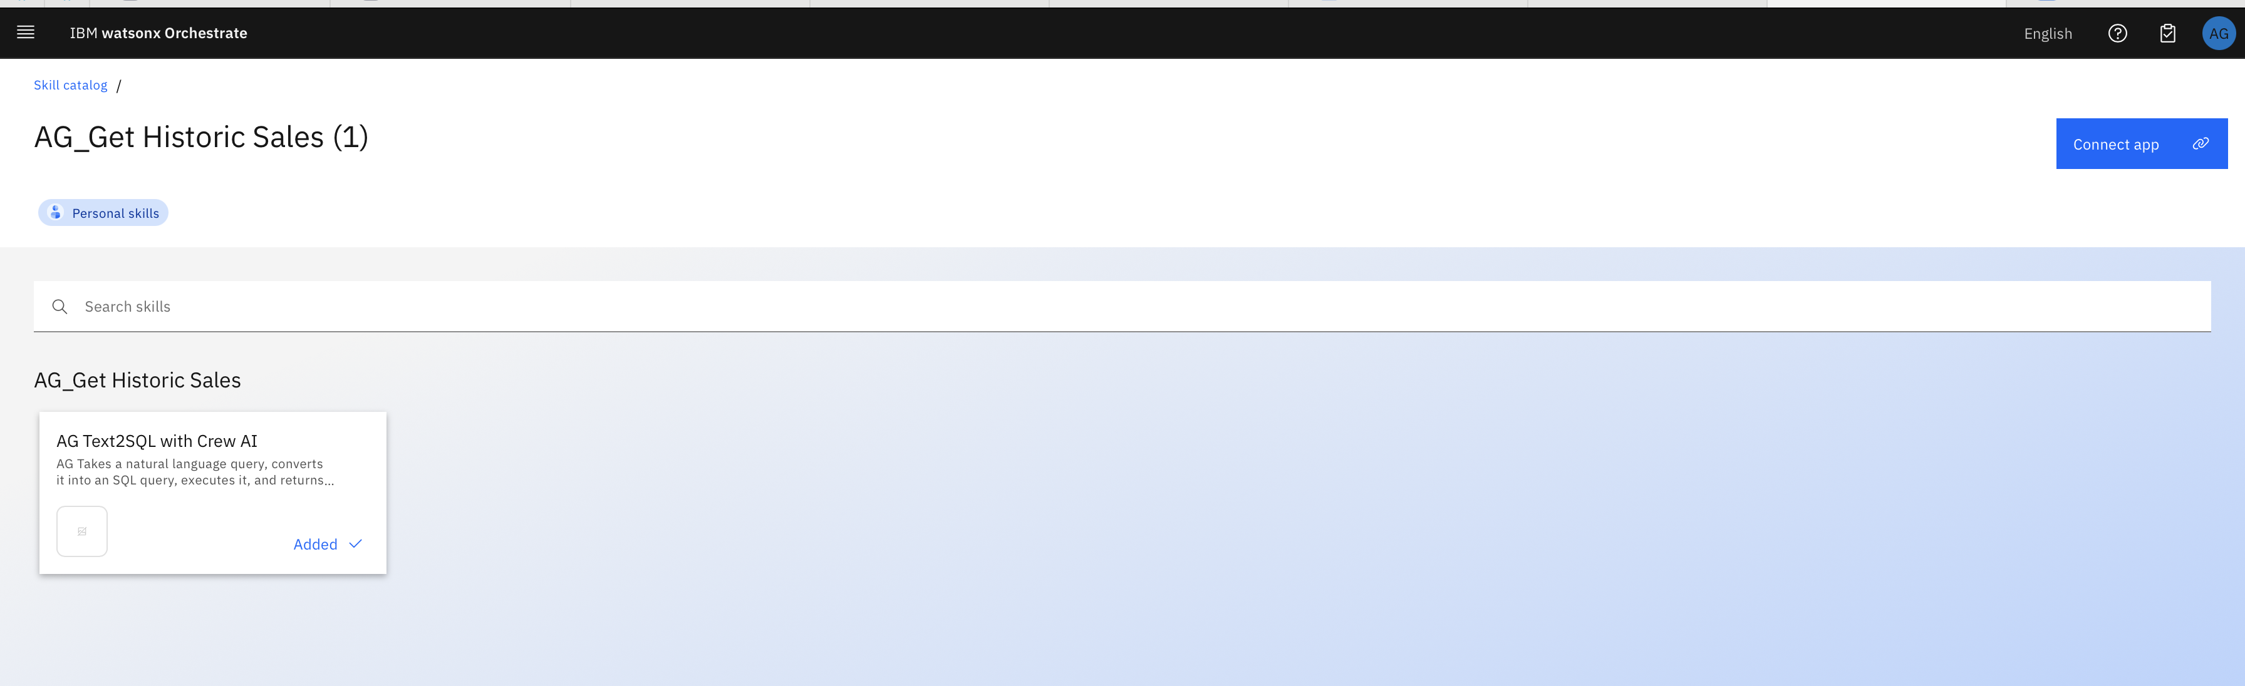

Use the following credentials to connect:

username: test

password: test

And then click on “Update App”/ “Connect App”.

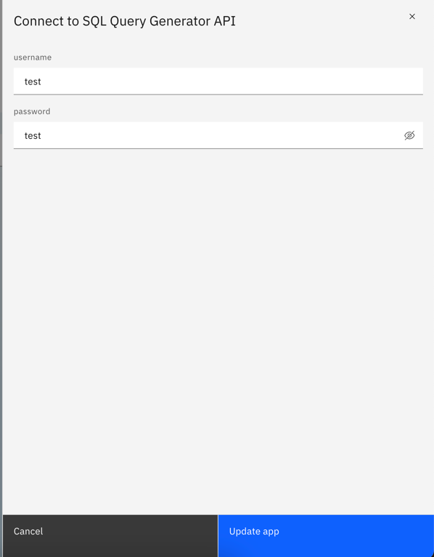

Now, you can see the following image:

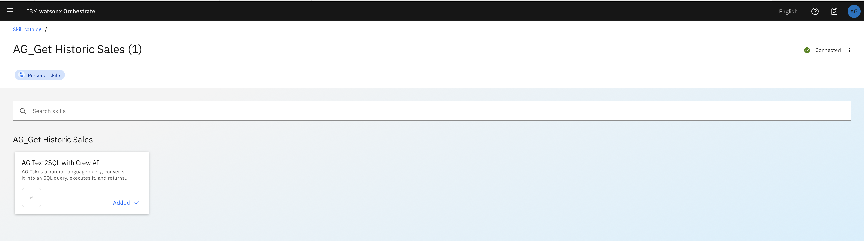

1. You will be able to see other custom skills within the catalog. These are preloaded and preconnected for all participants in the instance. So, you are required to add these skills one by one as we added “[YourName] Get Historic Sales”
   1. Calculate reorder quantity
   2. Salesforce custom skill
   3. Supplier Research
   4. TimeSeriesForecast
2. You will need to add these 4 skills into your personal skills. An example to add Calculate reorder quantity will be shown to you.
3. From **Skill Catalog**, search for Calculate reorder quantity app and click the tile.

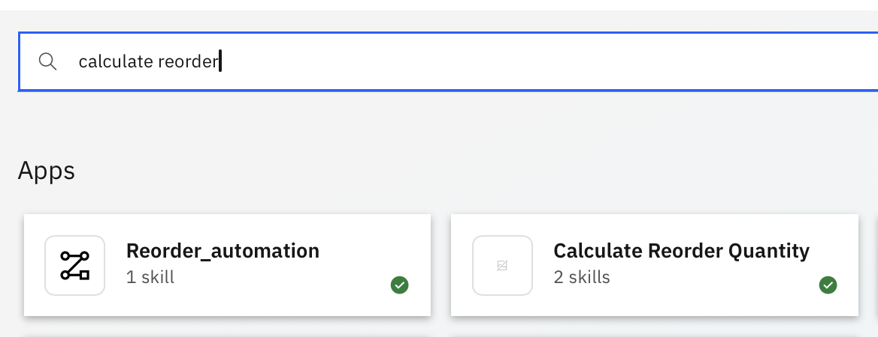

1. Add the skill.

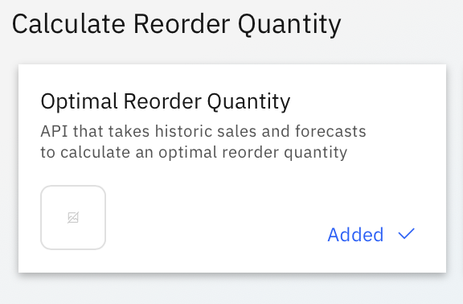

1. Repeat for the other two custom skill and add all skills within the different app into your personal skill.
   1. Salesforce Custom Skills

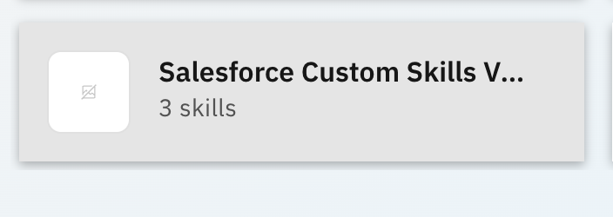

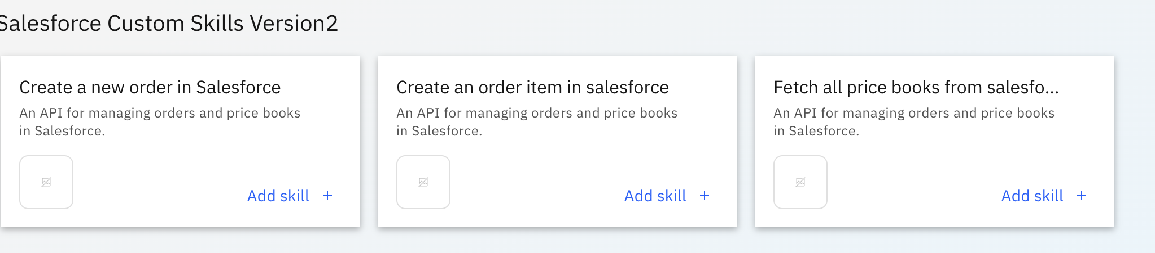

* 1. Supplier Research

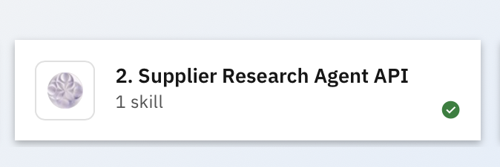

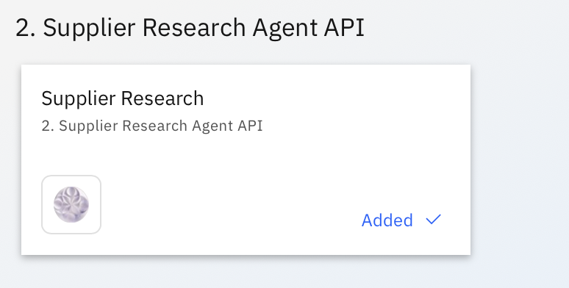

* 1. TimeSeriesForecast

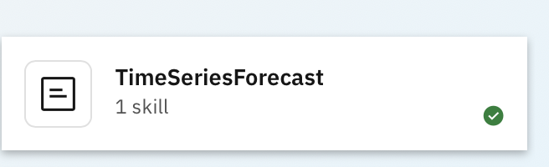

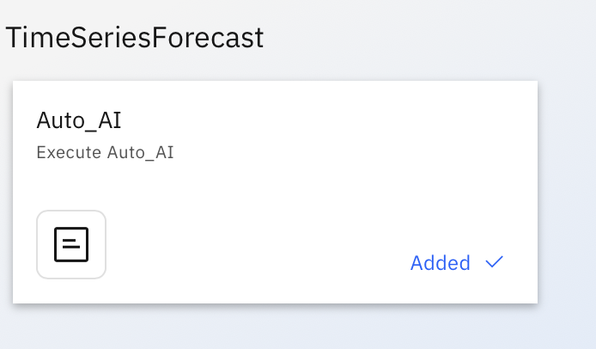

## [READ ONLY] Configure AI Agent with Custom Skill

Note:

* For this workshop, we’ve given everyone admin rights. If you notice you’re not one, feel free to contact the course owner.
* **For this workshop, we’ve added all apps and skills required. You can follow through the steps, but you DO NOT NEED to connect or add on the skills anymore.**
* **DO NOT** edit any skills credentials

1. Go to “Skill Sets” from the top left hamburger menu.



1. From the dropdown menu under skill sets, select “Orchestrate Agent Skillset”

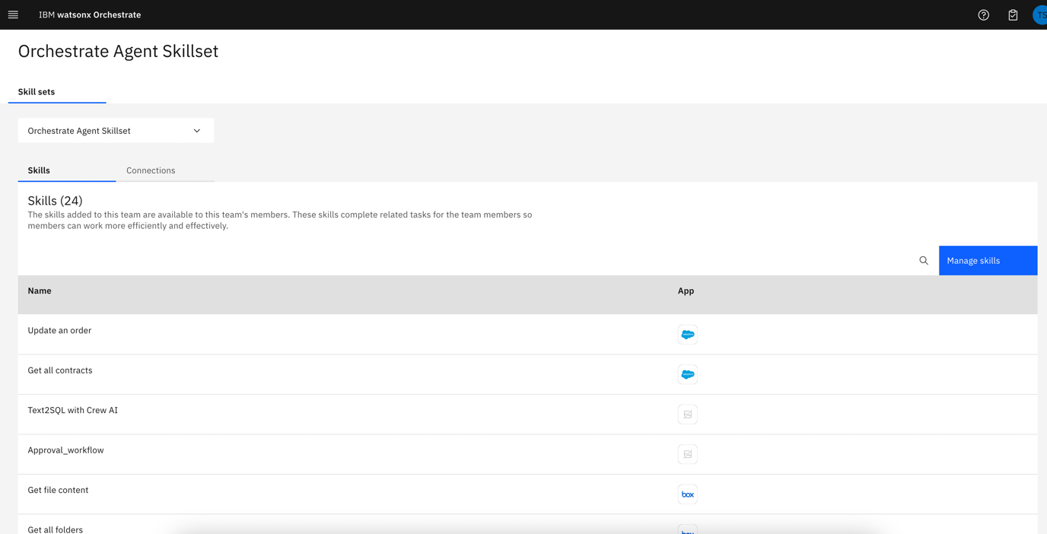

1. Next, select the Connections tab and search for “[YourName] Get Historic Sales” and “connect / Edit” connection.

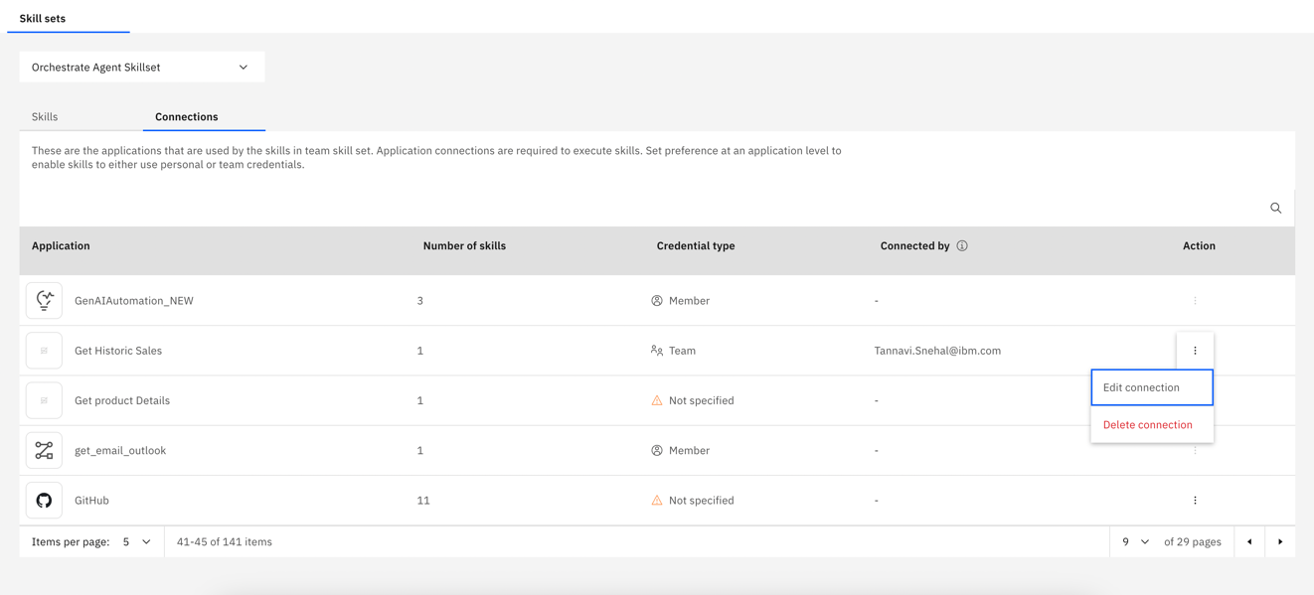

1. Connect the app by clicking on “Connect App” button and provide the following credentials, if it is not connected earlier:

username: test

password: test

Once successfully connected, select “AI Agent Configuration” from the left hand hamburger menu and then select “Apps and Skills” respectively.

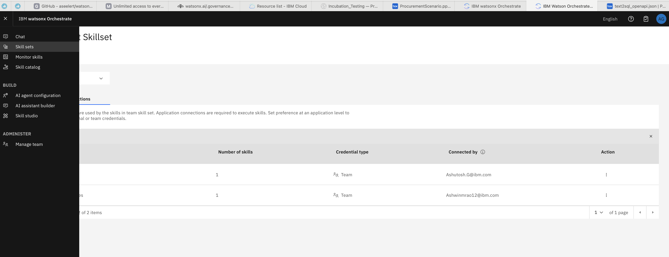

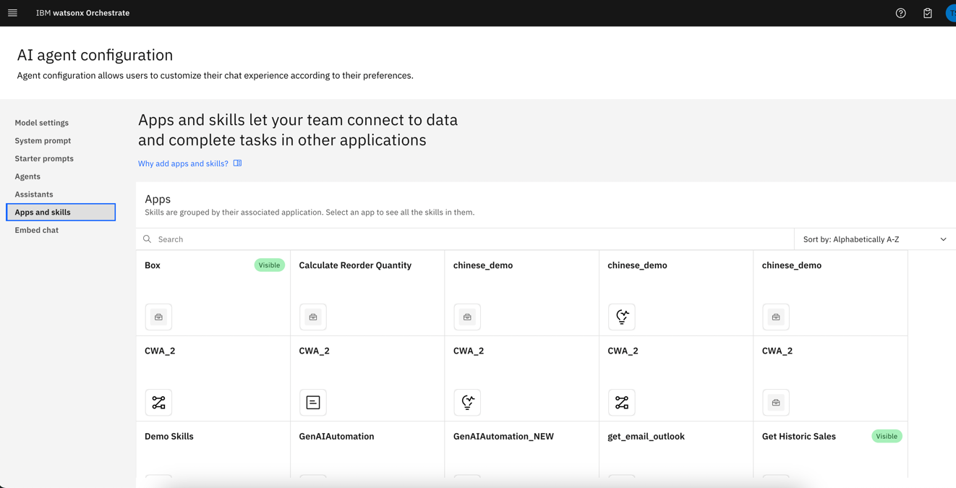

1. Search for “[YourName] Get Historic Sales” and click on it. You will see “Text to SQL with CrewAI” skill there and add this “Text to SQL with CrewAI” skill to AI Chat.

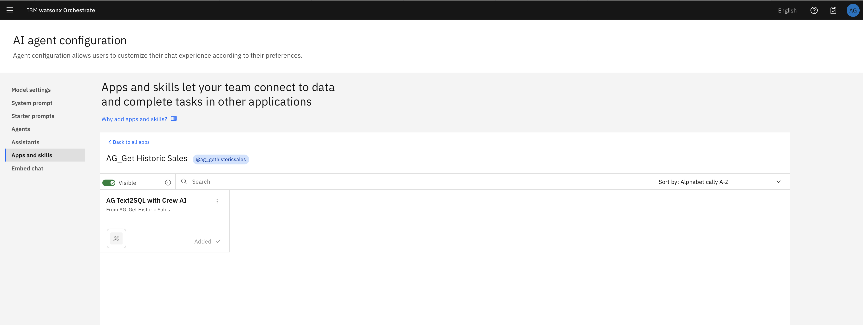

1. Click on “back to all apps” and Search for “TimeSeriesForecast” . You will see the following screen. Click on “Add skill” for adding “Auto_AI”, if not added.

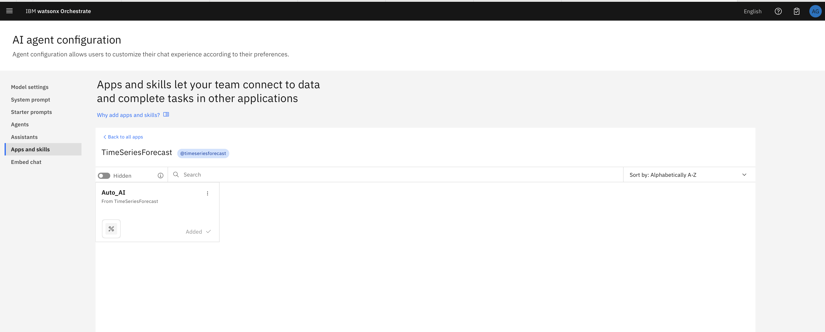

1. Go back to all aps and Search for “Calculate Reorder Quantity” and add the “Optimal Reorder Quantity” skill to AI Chat as we did earlier for others.

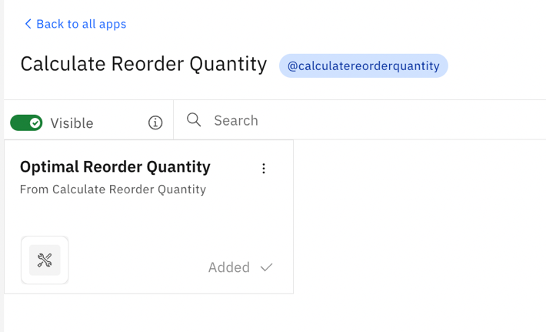

Now, we are done with the adding skills. Let’s check how the agent is behaving now with our queries.

## Test custom skills

Go to Chat window from top left hamburger menu and try the following queries:

1. What is the sales figure for Xtralife for the last 3 months?

Note: The agent will prompt the query again to double check. The response may take some time to populate.

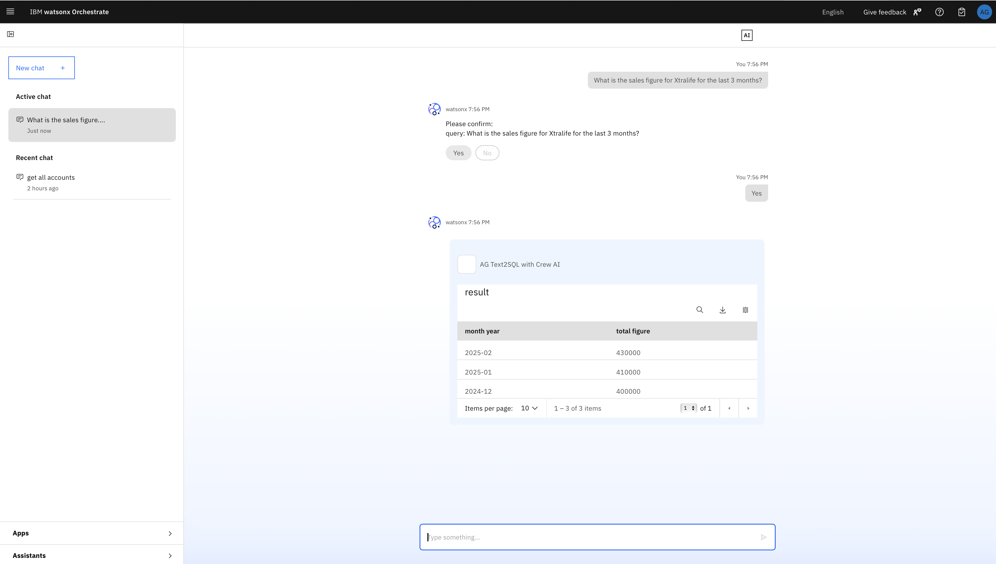

1. What is the quantity sold last year this month for Xtralife? (Activating @gethistoricsales)

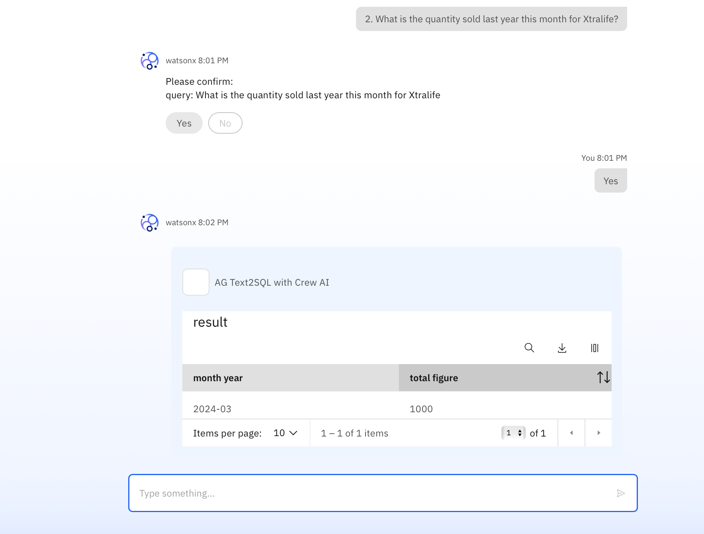

1. What is the forecasted sales and quantity for the next 3 months?

***When prompted to enter value for lastMonthSales and lastMonthQuantity, you can enter any value. Ensure lastMonthSales is much larger than lastMonthQuantity.***

(response from @timeseriesforecastautoai)

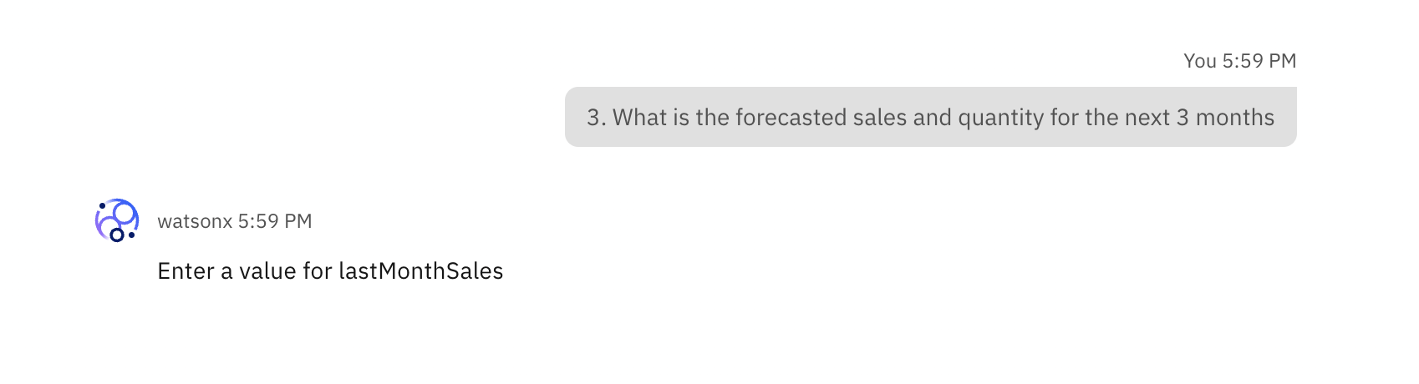

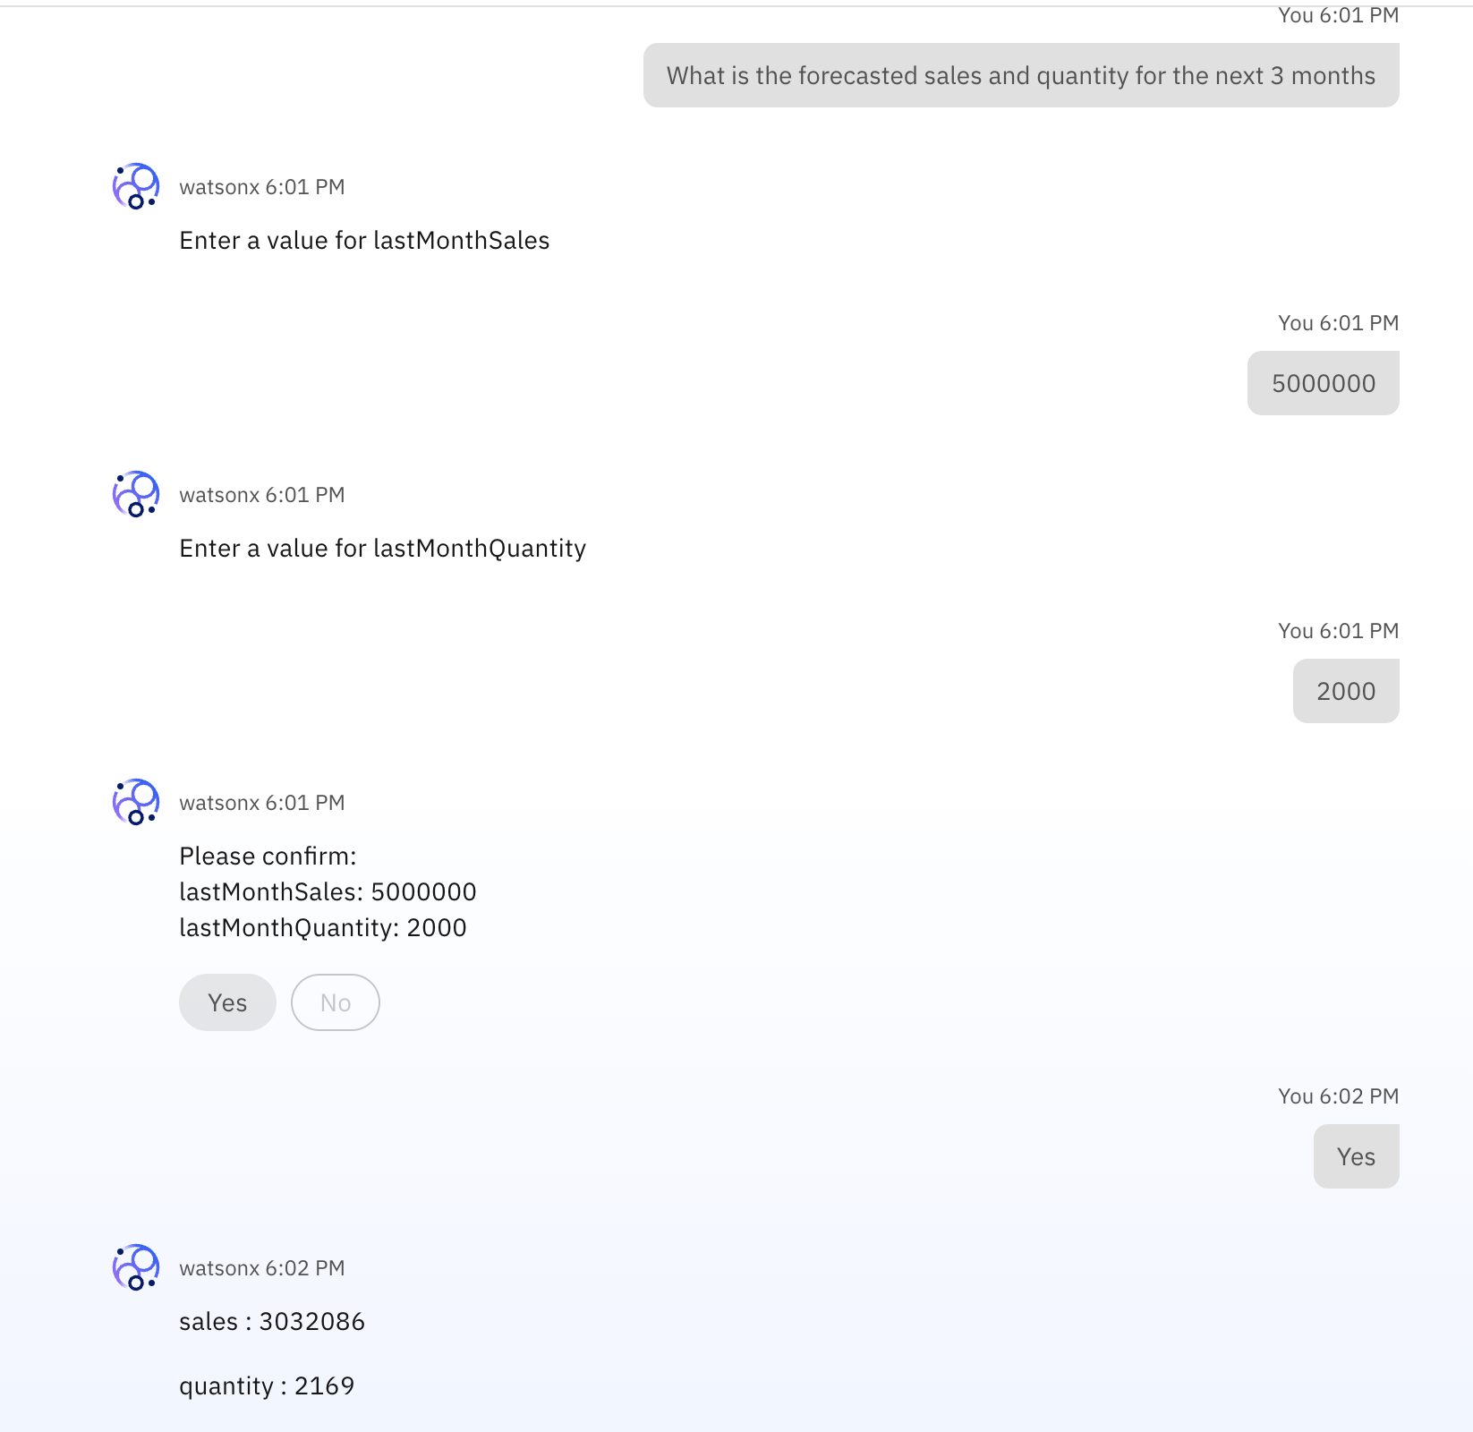

1. Let’s increase the complexities in the query. Ask the following query.

What should be the optimal reorder quantity if my current inventory has 1000 units, last month sales was 3400 units and forecast for the next month is 3107 units? (Generating from @calculatereorderquantity)

Here, you can see how the system is first extracted the relevant information and prompt to the user to check again and later generate the response with reasoning.

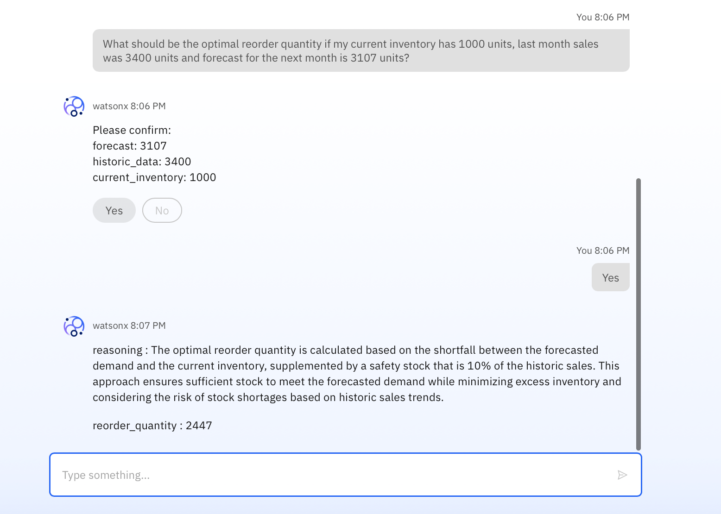

This is the end of the Lab 1.b